MODERN COLLEGE OF ARTS,SCI. & COMM. PUNE-05.

DEPARTMENT OF STATISTICS

EXPT.NO. 2

Title : Calculating and plotting ACF and ACVF

Q.1 Consider the following series of 70 conservative from a both of chemical process.

Estimate the auto covariance and auto correlation function for this time series data.

Also obtain the plot of auto covariance and auto correlation function.

|  |  |  |  |  |
| --- | --- | --- | --- | --- |
| (1-15) | (16-30) | (31-45) | (46-60) | (61-70) |
| 47 | 44 | 50 | 62 | 68 |
| 64 | 80 | 71 | 44 | 38 |
| 23 | 55 | 56 | 64 | 50 |
| 71 | 37 | 74 | 43 | 60 |
| 38 | 74 | 58 | 52 | 39 |
| 64 | 51 | 58 | 38 | 59 |
| 55 | 57 | 45 | 59 | 40 |
| 41 | 50 | 54 | 55 | 57 |
| 59 | 60 | 36 | 41 | 54 |
| 48 | 45 | 54 | 53 | 23 |
| 71 | 57 | 48 | 49 |  |
| 35 | 50 | 55 | 34 |  |
| 57 | 45 | 45 | 35 |  |
| 40 | 25 | 57 | 54 |  |
| 58 | 59 | 50 | 45 |  |

Q.2 Consider the data available in file C:\program\ minitabdata\employment rebased to employment in food preparation industry in Wisconsin. The data contains number of employees in three industries in Wisconsin. The wholesale and retail trade food and Kindred products and fabricated materials in each month are five years.

i) Obtain the time series plot of this data.

ii) Calculate the ACVF and ACF for 50 logs also obtain plot of ACVF and ACF

*********************************************************************

Answer-sheet :

## Q1)

library(tseries)

data=scan('clipboard')

t=ts(data)

t

# Autocorrelation plot

ACF=acf(t,lag.max = NULL,type = c("correlation"),plot = TRUE)

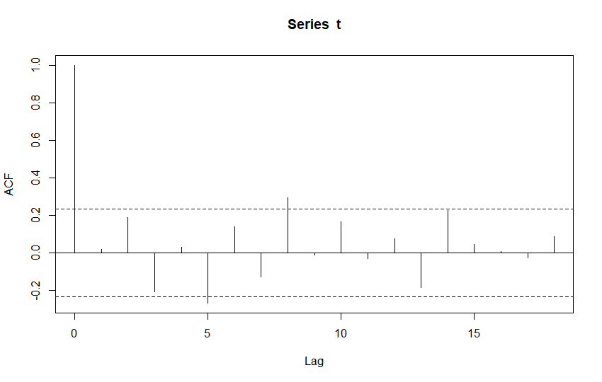

ACF

Autocorrelations of series ‘t’, by lag

0 1 2 3 4 5 6 7 8 9 10 11 12 13 14 15 16

1.000 0.017 0.187 -0.210 0.027 -0.270 0.138 -0.130 0.295 -0.012 0.165 -0.033 0.073 -0.185 0.225 0.043 0.007

17 18

-0.029 0.084

# Autocovariance plot

ACVF=acf(t,lag.max = NULL,type = c("covariance"),plot = TRUE)

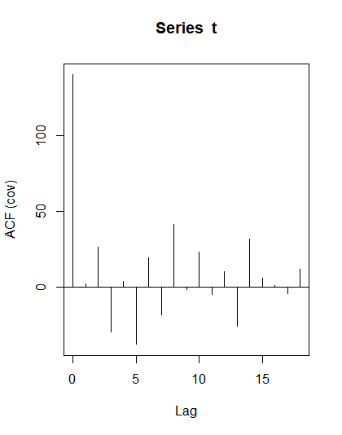

ACVF

Autocovariances of series ‘t’, by lag

0 1 2 3 4 5 6 7 8 9 10 11 12 13 14

140.441 2.405 26.205 -29.485 3.819 -37.898 19.381 -18.238 41.393 -1.731 23.145 -4.631 10.289 -25.925 31.576

15 16 17 18

6.054 0.981 -4.032 11.836

# Partial Autocorrelation plot

PACF=pacf(t,lag.max = NULL,plot = TRUE)

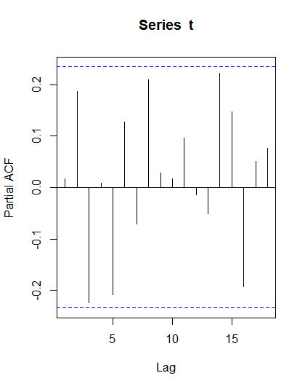

PACF

Partial autocorrelations of series ‘t’, by lag

1 2 3 4 5 6 7 8 9 10 11 12 13 14 15 16 17

0.017 0.186 -0.224 0.008 -0.208 0.127 -0.071 0.210 0.028 0.017 0.097 -0.015 -0.051 0.223 0.147 -0.193 0.051

18

0.076

From both the ACF and ACVF plot we can say that, the process is stationary as 95% of the points lie within the boundary limits.

## Q2)

library(tseries)

trade=scan('clipboard')

food=scan('clipboard')

metal=scan('clipboard')

d=matrix(c(trade,food,metal),nrow = length(trade),ncol = 3,byrow=FALSE)

# Time series plots

t=ts(d)

plot.ts(d)

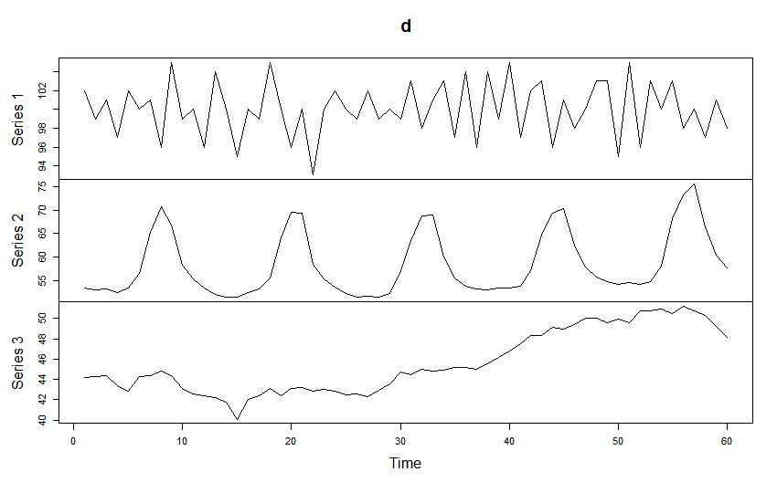 It can be observed from the above plots that the series is almost stationary

# Autocorrelation plot

ACF=acf(t,lag.max = 50,type = c("correlation"),plot = TRUE)

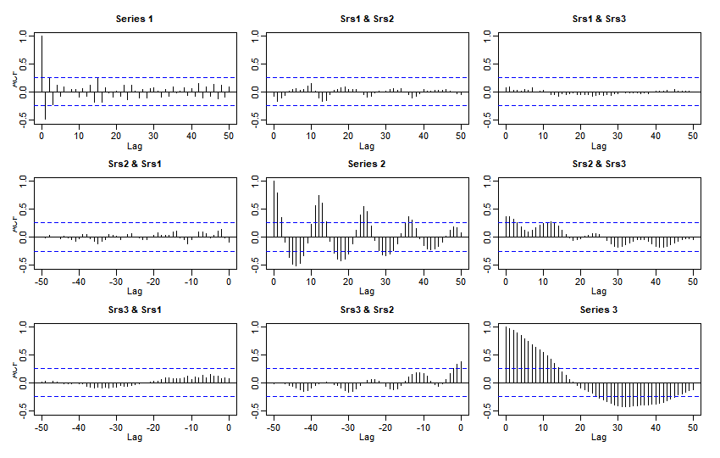

# Autocovariance plot

ACVF=acf(t,lag.max = 50,type = c("covariance"),plot = TRUE)

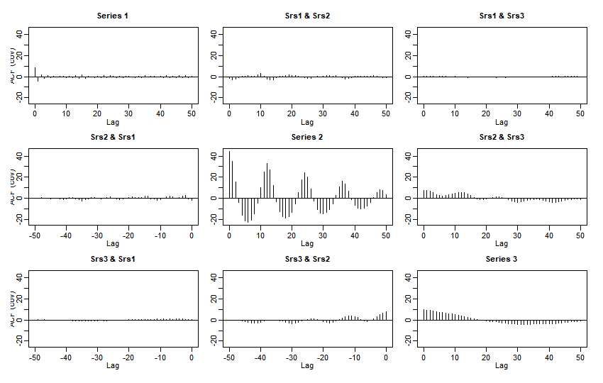

# Partial Autocorrelation plot

PACF=pacf(t,lag.max = NULL,plot = TRUE)

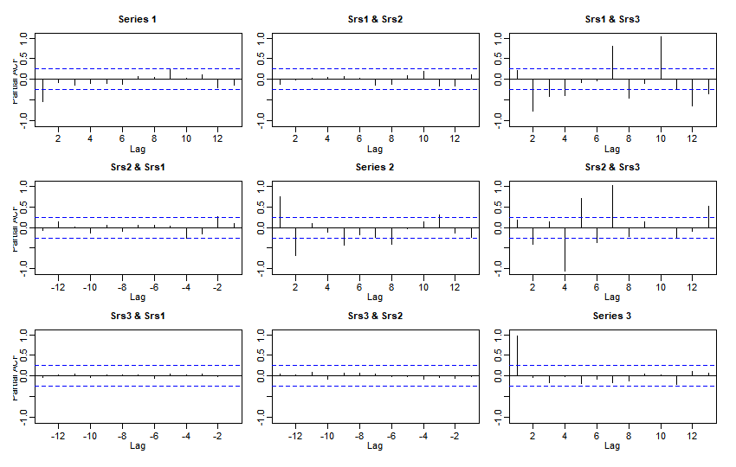

Interpretation :

From ACF plot of the food time series we can conclude that, since there are lot points which are either above or below the 95 % of the confidence interval. But the data might contain seasonality component.

From ACF plot of the metal time series, we can conclude that since most of the observation lie outside the 95 % of the confidence interval , hence we can conclude that the time series is not perfectly stationary.

A gradual decrease is the all the ACF plots and a sudden sharp decrease in PACF plots after the lag 1 concludes that AR(1) model is best suited for the given time series.